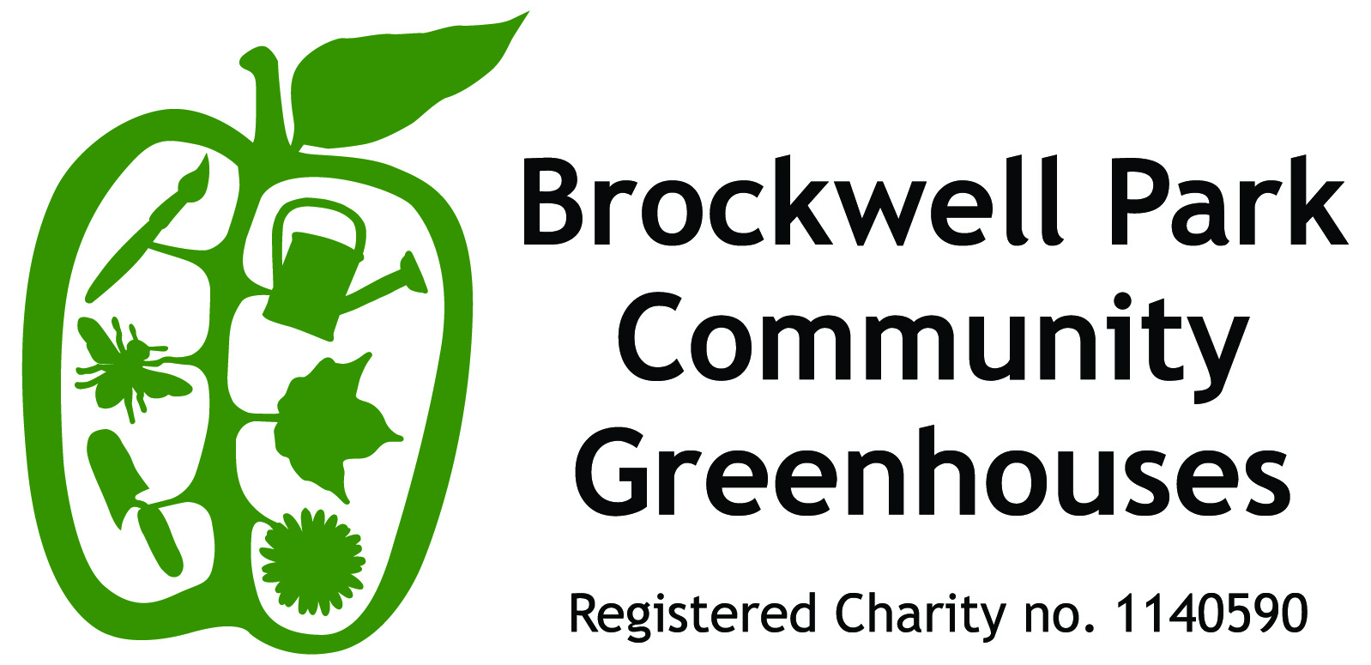

Volunteer Fundraiser
Brockwell Park Community Greenhouses is a vibrant community garden situated in the centre of Brockwell Park. The BPCG charity is committed to enabling a diverse range of local residents, schools and visitors to increase their knowledge, improve their wellbeing and to create greener communities. Our one-acre site is a thriving hub of volunteering activities and educational initiatives.
Our strap line is ‘Growing through learning, learning through growing’
We are currently looking for a Volunteer Fundraiser to help us raise funds for the charity and sit on our Board of Trustees.

Responsibilities:
- Assist with identifying and securing funding for the charity especially for building developments to incorporate dedicated teaching space, improved volunteer facilities and a teaching kitchen to deliver “plot to plate” cooking.
- Fundraising to be via a variety of methods and from a variety of sources including from trusts, government bodies, business and members of the public.
- Working with our trustees and community stake-holders to set and implement the strategic plans of the charity.
- Identifying and consolidating partnership opportunities which respond to community need, can attract independent funding and/or generate income for the charity.
- Raising the profile of BPCG through local and wider relevant networking.
- Attending and reporting to our six Trustees meetings and the Annual General Meeting.
- Abiding by BPCG policies and procedures
.
Person Specification
Experience: Ideally, the candidate should be able to show experience and familiarity of most of the following:
- Preparation of fundraising or grant applications, reports and presentations
- Experience of a wide variety of fundraising platforms including:
  - Government grant funding
  - Crowd-funding
  - Legacy fundraising
  - Independent Trusts
- Knowledge of Lambeth and Southwark Public Sector
- Knowledge of Third Sector
- Strategic long term planning

Skills and attributes
In addition, the candidate should be
- Enthused by the work of the Community Greenhouses
- Pro-active, self-motivated and highly organised
- A confident and effective communicator both verbally and in writing
- An excellent networker
- Numerate and able to use word processing and spreadsheet software
- Committed to working as part of a team
- Able to accommodate differing viewpoints with sensitivity and tact.

Hours
This voluntary position requires a commitment of up to 2 days spread over a month – to be done at any time of the day/week although an ability to do a small part of this during normal office hours would be useful.
The Volunteer Fundraiser would also be expected to attend the six Trustee Meetings in the year and the Annual General Meeting.
The candidate who can commit to the charity and provide this sought-after expertise voluntarily will be making a huge difference to the charity and their support will be greatly appreciated.
BPCG is committed to promoting equality and diversity within the organization and to Equal Opportunities in its recruitment and employment practices.
BPCG is committed to safeguarding and promoting the welfare of children, young people and vulnerable adults and expects all staff and volunteers interacting with these groups to share this commitment.

